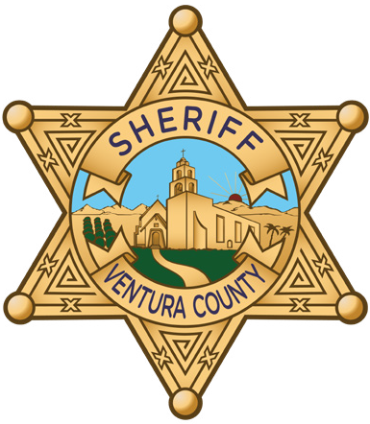

Nature of Incident: | FEMA Extends Public and Individual Assistance to Ventura County
Location: | Ventura County, California
Date & Time: | 02/02/2023 @ 3:00 p.m.
Unit(s) Responsible: | Ventura County Sheriff Emergency Services, Ventura County Public Works Agency, Ventura County Executive Office
Narrative:
The January storms resulted in widespread damage across Ventura County, prompting Sheriff Jim Fryhoff to sign a Proclamation of Local Emergency. This proclamation was later ratified by the Ventura County Board of Supervisors and sent the California Governor requesting his support for the Major Disaster Declaration. Subsequently, and with unanimous support of local congressional delegates, a Major Disaster Declaration was authorized by President Biden, to include Ventura County. This Major Disaster Declaration is key to activating various disaster assistance programs for residents, businesses and public agencies.

On January 26, 2023, Ventura County was awarded all categories of the Federal Emergency Management Agency’s (FEMA) Public Assistance Grant Program. This federal program will assist local public agencies in completing over $30,000,000 in repairs and clean-up caused by recent storms. This includes the repair of Matilija Canyon Road, the Ventura Pier, replacement of the Ojai Valley Sanitation District’s wastewater pipeline, repair to County of Ventura parks and much more.

On February 1, 2023, the Major Disaster Declaration was amended to include Ventura County in the designation for FEMA Individual Assistance. The FEMA Individual Assistance program will provide direct financial support to Ventura County residents impacted by the storm including payments for temporary housing needs, cleanup of mud and other stormed-related debris, completion of repairs or limited reconstruction, and replacement of other needed personal items. Eligibility for this program is determined on an individual basis and assistance is provided in the form of grants that do not require repayment.

Individuals wishing to file a claim may find more detailed information regarding the program and links to the FEMA Individual Assistance application at www.vcemergency.com.

Prepared by: |  | Patrick Maynard, Director, Ventura County Sheriff Emergency Services
News Release Date: |  | 02/02/2023
Media Follow-Up Contact: |  | Patrick Maynard 805-654-3843

###

